Contents
REQUEST FOR PROPOSAL FOR EXTERNAL MANAGERS OF THE FOREIGN RESERVES BANCO DE LA REPÚBLICA 2024 1
Schedule of the RFP 2
Terms and Conditions of the RFP 3
The Bank’s Investment Management Agreement 5
Certification as to Satisfaction of the Minimum Selection Criteria for Consideration 6
Required Minimum Selection Criteria: 6
The Candidate must meet each of the following: 7
Certification 8
Additional Documentation 8
The Questionnaire 9
SECTION A – THE FIRM (information must refer to the Candidate’s asset management business unit/division unless otherwise stated) 9
SECTION B – CUSTOMER SERVICE 11
SECTION C - INVESTMENT PROCESS / RISK MANAGEMENT 18
SECTION D – TRAINING / KNOWLEDGE TRANSFER 22
SECTION E – HISTORICAL PERFORMANCE 22
SECTION F – LEGAL, COMPLIANCE AND OTHER MATTERS 23
Annex 1. Instructions for the Proposal 25
Annex 2. Compliance Certification 26
Annex 3. Authorization for the processing of personal data (image) of a person of age for internal use by Banco de la República 27

REQUEST FOR PROPOSAL FOR EXTERNAL MANAGERS OF THE FOREIGN RESERVES BANCO DE LA REPÚBLICA 2024

Since 1994, Banco de la República (the “Bank” or “BdlR”) has been successfully running an External Management Program. The main objectives of the program are to: (a) enhance the performance of Colombia’s Foreign Reserves Investment Portfolio; (b) provide training and transfer of knowledge to the Bank’s staff; and (c) support the Bank’s research efforts and the management of the reserves where needed.
The International Reserves Committee of the Bank (the “Committee”) has approved a selection process for a new external asset manager. The Bank is issuing this Request For Proposal (the “RFP”) from asset managers specializing in short-duration fixed income portfolios to manage a portfolio with an allocated ex-ante tracking error of 100 basis points per annum.
Funding for the new investment portfolio will be provided in cash or a mixture of cash and securities, with the new asset manager to invest such funds in accordance with investment guidelines approved by the Committee. Permissible investments are concentrated in government bonds, however, within strict limits, investments are also allowed in debt of high-quality issuers, such as quasi-governments, supranational organizations, agency MBS, banks and corporations. The minimum credit rating is A+ / A1 for banks and corporations and A- / A3 for governments and quasi-governments. The current benchmark portfolio is invested in US dollars, euros, Canadian dollars, and Australian dollars. Other eligible currencies are British pounds, New Zealand dollars, Swedish kronor, Japanese yen, Singapore dollars, Hong Kong dollars, Swiss francs, offshore Chinese renminbi, Korean won and Norwegian kronor. For currency and interest rate risk management, currency forwards and futures contracts on interest rates and government bonds are allowed. Additionally, as of December 31st, 2023, the benchmark portfolio duration was close to 2.8. Further details regarding the Foreign Reserves Management and the External Management Program can be found on the Bank’s website at https://www.banrep.gov.co/en/foreign-reserves-management-2021.
In order to participate in the selection process set forth in this RFP, each prospective participant (a “Candidate”) should submit a Proposal (as defined in Annex 1 attached hereto). To satisfy the minimum eligibility criteria the Candidate must meet each of the following: (1) at least US$50 billion in fixed income assets under management across the Candidate’s asset management business unit/division as of December 31 of the last five years (2019 to 2023), (2) minimum experience of ten (10) years in fixed income management for institutional investors across the Candidate’s asset management business unit/division, (3) at least US$14 billion in fixed income assets under management as of December 31 of the last five years (2019 to 2023) by the legal entity that will, if its Proposal is selected, enter into an investment management agreement with the Bank and be responsible for the performance of all obligations under such Agreement (the “Responsible Party”), and (4) an asset-liability ratio greater than one (1). Candidates may not include any third-party entity as part of their Proposal. Existing investment managers of the Bank, their Affiliates, and any other firm or Affiliate of any firm that has served the Bank as a manager of the Bank’s Foreign Reserves on or after December 31, 2018, will not be eligible for consideration.
Custody services are not being solicited pursuant to this RFP. Custody for the Bank’s assets is provided by the Bank’s existing custodians, as described below, and Candidates (or their Affiliates), if its Proposal is selected, will not be permitted to custodialize the Bank’s assets.

Schedule of the RFP
The proposed schedule for the selection process of this RFP is as follows:
- Questions about the RFP or the selection process should be sent by electronic mail to Investmentmanager2024@banrep.gov.co on or prior to May 17th, 2024 (23:59 Bogotá time). The Bank will endeavor to respond to such questions by publishing the answers on its website approximately two (2) weeks later.
- Candidates responding to this RFP must provide a Proposal to the Bank consisting of (i) Certification as to Satisfaction of the Minimum Selection Criteria for Consideration, (ii) Compliance Certification (in the form of Annex 2 attached hereto), (iii) Additional Documentation, and (iv) the Questionnaire. Proposals must be received by the Bank on or prior to June 14th, 2024 (23:59 Bogotá time). Please refer to Annex 1 for specific instructions which must be strictly adhered to.
- The Bank will evaluate the Proposals and will endeavor to inform each participant whether it has been chosen as a finalist on or prior to September 2024.
- Officers from the Bank anticipate visiting finalists in their offices or conducting telephone or video conferences as required in order to gain a better understanding of the key aspects of their proposal. The Bank expects such visits or meetings to occur during October/November 2024, in each case based on the Bank’s schedule. At this stage, the Bank will also send the finalists due diligence questions aiming to strengthen the Bank’s understanding of the finalists’ risk management framework.
- Following visits or meetings (in person, telephone, or video conferences) with the finalists, each of the finalists will be required to submit a fee proposal and to present confirmation of such finalist’s willingness to accept the Bank’s standard Investment Management Agreement (a copy of which will be provided to each finalist).
- The Bank will endeavor to communicate the results of the process to the finalists by February 2025.

Terms and Conditions of the RFP
During this process we request that participants refrain from directly contacting any officer of the Bank about this RFP or the selection process effective immediately upon the release of this RFP and continuing until the review and evaluation process is completed. We also ask that you do not include any generic marketing or sales information, or rely on cross-references to other documentation, in your responses.
This RFP does not commit the Bank to award a contract. The Bank reserves the right, in its sole discretion, to accept or reject any or all Proposals, to negotiate with any or all Candidates, or to cancel, amend or postpone this RFP in whole or in part, at any time. The Bank does not assume and shall not have any responsibility, liability or obligation to any person in connection with this RFP or its analysis or assessment of any or all responses (including Proposals) to the RFP, and the Bank reserves the right, in its sole discretion, not to appoint any new external asset manager, or to choose one or more external asset manager(s) based on whatever criteria it deems necessary and appropriate at any time. The Bank will not have any obligation to specify the reasons, either in general or specific terms, at any stage in the process, for not accepting a particular participant’s response or for terminating the selection process. If the Bank decides to award this RFP, in whole or in part, the Bank will then begin contractual discussions with the selected Candidate(s) and, contingent on the outcome of these contractual discussions, the Bank may or may not proceed with the execution of the Investment Management Agreement with the selected Candidate(s). Alternatively, the Bank may begin contractual negotiations with one or more Candidate(s) but determine to proceed to the execution of the Investment Management Agreement with different Candidate(s), including in circumstances where the first Candidate(s) are not able to proceed with its Proposal on its previously indicated terms, without incurring any liability to any person. Such alternative selection of Candidates will not constitute an amendment, modification or termination of the RFP or any aspect of the selection process with respect thereto.
The Bank will not reimburse any Candidates for any expenses incurred in preparing or submitting Proposals or providing information to the Bank in connection with such Proposals. The Bank reserves the right to retain all Proposals submitted and to use any ideas in any Proposal regardless of whether such Proposal is selected by the Bank.
To the extent permitted by applicable law, the Bank and the Candidates will treat as confidential any information provided to each other in connection with this selection process, unless such information is otherwise made public by a person other than the Bank or the applicable Candidate.
At its sole discretion, the Bank reserves the right to conduct interviews of finalists remotely via telephone or videoconference (e.g., Microsoft Teams, Webex, Zoom) in lieu of in-person meetings. The Bank also reserves the right, at its sole discretion, to record such telephone or videoconference interviews. The Responsible Party shall be solely responsible and liable for ensuring that all of the employees of the Responsible Party and other persons attending the interviews on its behalf have provided all consents and authorizations as required by applicable laws and regulations for the Bank to record such telephone or videoconference interviews. Prior to such interviews, the Responsible Party shall send to the Bank via e-mail to this e-mail address: Investmentmanager2024@banrep.gov.co, the executed form provided in Annex 3, duly executed by the employees of the Responsible Party and other persons attending the interview. Should applicable laws or regulations require that additional undertakings be made in order to effectuate the consents and authorizations contemplated herein, the Responsible Party shall ensure those undertakings are fully made, and to the extent necessary shall be addressed through appropriate language added to each executed Annex 3.
In the event that personal data is provided to the Bank in the course of this selection process (by written means or through telephone or videoconferences that would be recorded), the submittal of a Proposal means the Candidate is authorized by the respective data subjects and accordingly, the Candidate authorizes the Bank to receive this information as well as to its treatment (by collection, storage, use, circulation, or erasure) by the Bank of all information provided in the course of the selection process and in connection with the negotiation and fulfillment of the Investment Management Agreement derived from this selection process (including any subsequent amendment or termination thereof), as well as for surveys, the development of studies and analyses regarding this selection process including the construction of indicators and statistics for monitoring and control of these activities, and those within the competence of the Bank.
The Bank hereby informs Candidates that the processing of personal data will be made in accordance with the general policies or guidelines available at https://www.banrep.gov.co/en/general-policies-and-guidelines-personal-data-protection.
In the event that due to the participation in this selection process, the Candidate has access to or treats (by collection, storage, use, circulation, or erasure) third-party personal data, the Candidate shall comply with the corresponding personal data regulation applicable to the same.
Prospective managers may be requested to clarify the contents of their Proposal. Other than to provide such information as may be required by the Bank, no prospective manager will be allowed to amend its Proposal or to add new information after the RFP due date, including to substitute the entity that is its proposed Responsible Party. If a prospective manager discovers any ambiguity, conflict, discrepancy, omission, or other error in this RFP, please immediately notify the Bank of such error before May 17, 2024, and request clarification or modification of the document. If it becomes necessary for the Bank to revise any part of this RFP or if a more exact interpretation of provisions of this RFP are required prior to the due date for Proposals, a supplement will be posted by the Bank on its website. If such addenda issuance is necessary, the Bank reserves the right to extend the due date of Proposals to accommodate such interpretations or additional data requirements.
Fee proposals provided by finalists will be firm for a period of 365 days following communication of the final decision by the Bank and may not be changed following submission. The term of the proposal may be extended upon request by the Bank. If a Candidate fails to notify the Bank of a known error in such Candidate’s Proposal or in this RFP or such error could reasonably have been known prior to the final filing date for such Proposal, the Bank will evaluate the measures to be adopted. If awarded the contract, such Candidate shall not be entitled to any compensation by reason of such error or its correction at any time.
Notwithstanding any other provision of this RFP, the Bank reserves the right to reject any or all Proposals or to waive any informality in any Proposal. Please note that the Bank is not required or committed to accept the lowest bidder to this RFP. The Bank will consider each Candidate's experience in the investment advisory field and with similar clients on related projects. Further, the Bank will consider each Candidate’s detailed responses to each section of the RFP (including the Proposal), such Candidate’s interviews with the Bank, and such Candidate’s presentations to the Bank. Conditions described in these specifications should be closely adhered to.
Please note that non-responsive Proposals include, but are not limited to, such Proposals that:
- Are irregular or not in conformance with all RFP requirements and instructions.
- Are conditional, incomplete, indefinite or ambiguous.
- Are not submitted on time.
If more than one Affiliate of the same group participates in this RFP process as Candidates, only one of them will be eligible to be selected by the Bank as an investment manager.
The Bank may waive minor informalities in any Proposal in a manner that the Bank, solely upon its own determination, has deemed would not be prejudicial to any other Candidate(s).

The Bank’s Investment Management Agreement

The Bank has a standard Investment Management Agreement (either New York or English law) that it signs with each of its managers within the External Management Program. A Candidate’s willingness to accept the Bank’s standard Investment Management Agreement will be among the factors used in evaluating Candidates. Please note that the Bank expects that this Investment Management Agreement will only be subject to minor modifications and discussion.
Under the Investment Management Agreement, external managers have discretion as to which assets and securities to trade (within the Bank’s investment guidelines). However, if an asset / security is established under or traded pursuant to an agreement (e.g., under an ISDA Master Agreement or a MSFTA) that is in the name of or binding on the Bank (a “Manager Agreement”), the Manager Agreement must comply with certain required terms that will be specified in the Investment Management Agreement. These required terms are principally focused on the following matters: (i) limitation of recourse for losses arising out of the investment activities of the external manager to the assets under management with the external manager (except to the extent permitted by applicable law), (ii) limitation of liens and payment and other netting under the given Manager Agreement to assets managed by the external manager, and not other portions of the Bank’s assets or the Foreign Reserves generally and (iii) reservation of the Bank’s sovereign immunity (collectively, the “Required Terms”). Please note that the Bank is focused on maintaining its sovereign immunity to the maximum extent possible, and that the Bank expects its external managers to not agree to waivers of, and specifically reserve, the Bank’s sovereign immunity (or negotiate modifications of any such waivers found) in Manager Agreements.

Certification as to Satisfaction of the Minimum Selection Criteria for Consideration
Each Candidate must meet all the criteria as listed in the “REQUIRED MINIMUM SELECTION CRITERIA” section for its Proposal to be considered.
The Candidate must be the party that will, if its Proposal is selected, enter into the Investment Management Agreement with the Bank and perform the functions described in the definition of “Responsible Party” above, and no substitutions of entities to be the “Responsible Party” will be accepted following submission of a Proposal to the Bank.
It is important to note that the following entities will not be eligible for consideration: (i) existing external managers, (ii) entities that have worked with the Bank as external managers of the foreign reserves on or after December 31, 2018, and (iii) Affiliates of entities described in clauses (i) and (ii). If more than one affiliated entity participates in this process, only one affiliated entity will be eligible to be hired by the Bank.

Required Minimum Selection Criteria:
For each criterion, the Candidate must initial alongside such criterion indicating that the Candidate has met the conditions and providing the requested information.

The Candidate must meet each of the following:
- The Candidate’s asset management business unit/division has at least US$50 billion in fixed income assets under management as of December 31 of the last five years (2019 to 2023) ___________ (Initial).

- Please include in your response the following information as of December 31, for each year (in USD billion):
Fixed Income Assets Under Management of the asset management business unit/division
2019 | 2020 | 2021 | 2022 | 2023
- The Candidate's asset management business unit/division has more than 10 years of experience managing fixed income portfolios for institutional clients as of December 31, 2023. ___________ (Initial).

- Please indicate the Candidate’s asset management business unit/division years of experience managing fixed income portfolios for institutional clients:

- The Responsible Party has at least US$14 billion in fixed income assets under management as of December 31 of the last five years (2019 to 2023). ___________ (Initial).

- Please include in your response the legal name of the Responsible Party and the following information as of December 31, for each year (in USD billion):
Legal Name of Responsible Party: __________________
Fixed Income Assets Under Management of the Responsible Party
2019 | 2020 | 2021 | 2022 | 2023
- The Candidate has an asset-liability ratio greater than one (1) as of December 31, 2023. ___________ (Initial).

Certification
By signing below, the Candidate represents and warrants that the Candidate (i) meets all of the REQUIRED MINIMUM SELECTION CRITERIA as detailed above; (ii) is capable of performing all services as asset manager as contemplated by this RFP; (iii) understands and agrees to the terms and selection process set forth in this RFP (including the provisions described under the “The Bank’s Investment Management Agreement” heading above); (iv) has carefully reviewed this RFP and has submitted accurate responses in the Proposal; and (v) acknowledges and agrees that, if selected as an external manager of the Bank in accordance with this RFP, the Candidate will have a fiduciary duty to the Bank to perform its services as asset manager acting in the best interests of the Bank.
By: ____________________________
Name:
Date:

Please provide (i) a Compliance Certification (in the form of Annex 2 attached hereto) duly signed and (ii) a Certificate of Incumbency attesting to the signatory’s authority to sign the Compliance Certification and to make this certification.

Additional Documentation
Candidates must also provide the following documents or their equivalents for the Responsible Party:
- Audited financial statements as of December 31, 2023
- Certificate of good standing
- Certificate of incumbency for authorized signatories
- Registration as investment advisor
- Compliance Certification duly signed (in the form of Annex 2 attached hereto)
- SOC 1 or ISAE 3402 report issued by an independent auditor on the effectiveness of your internal controls for 2023.
Candidates are only expected to send the most recent documentation. If any of these documents cannot be provided, please provide a brief explanation.

The Questionnaire
Please include in your response to the questionnaire the name and contact information of the persons who will be involved in this RFP process.
Please answer the following questions completely and avoid inaccurate, vague or partial answers. Be aware that any unanswered question or table and/or any incomplete response or table will receive the minimum score applicable.
Answers to the tables should be provided in the attached excel spreadsheet named “rfp-tables-2024.xls”. The Bank expects to receive it as a separate file in the email (excel spreadsheet).
For your information, the Questionnaire’s sections will be evaluated as follows (technical evaluation):
Category | Weights
Firm | 30%
Customer Service | 10%
Investment Process / Risk Management | 30%
Training / Knowledge Transfer | 20%
Historical Performance | 10%

The final evaluation will depend on the technical evaluation (adjusted based on the insights gathered during the visits or telephone or video conferences) with a weight of 80%, and the economic evaluation (fee proposal) with a weight of 20%.

SECTION A – THE FIRM (information must refer to the Candidate’s asset management business unit/division unless otherwise stated)
- Please provide a brief description of the firm, including the legal name of the Responsible Party (including the relevant office location of such entity), ownership and capital structure, affiliated companies (including relevant relationship information, such as level of ownership and common management).

- Please answer the following questions succinctly:
- What other financial services does the firm provide?
- In which jurisdiction is the firm incorporated? If the firm outsources asset management to one or more affiliates, please provide the name and jurisdiction of incorporation of each such affiliate.
- The Bank’s External Management Program works under a performance-based fee schedule. Please acknowledge that the firm would be willing to work with this type of fee schedule.
- Would the firm provide / receive any advice or investment strategy to the Bank through or from any subadvisor, affiliate or other agent? If so, please describe what entity(ies), their place of incorporation and your relationship.
- Would the firm utilize or partner with any subadvisors, affiliates or other agents in the provision of services to the Bank? If so, please describe what entity(ies), their place of incorporation, the location(s) from which services are expected to be provided, and the relationship with them.
- List the awards or other recognition that the firm or its employees have received during the last five (5) years.

- Please provide contact information for three (3) to five (5) current client references with mandates similar to the one proposed by the Bank. All information will be kept confidential.

- Please provide any additional information not included above about the firm that supports its qualification to manage a fixed-income portfolio for a central bank.

- Please provide the following information as of December 31, 2023 (in USD million):
Table A1
* Each of the categories is independent from each other, meaning they are not necessarily subgroups of the other categories.
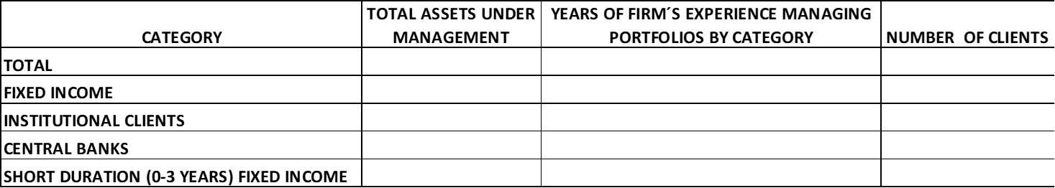

- Please provide the following information as of December 31, for each year (in USD million):
Table A2
* Each of the categories is independent from each other, meaning they are not necessarily subgroups of the other categories.
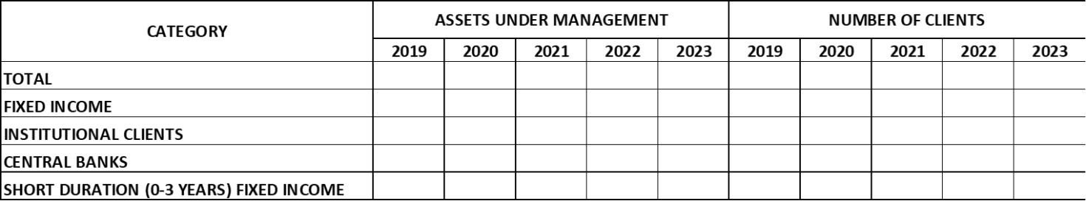

- Please complete the following table (Please allocate assets only to one category):
Table A3
* The Government related sector is composed by the following subsectors: supranational, government guaranteed agencies, government owned agencies / government sponsored agencies and local authorities, other than agency MBS.
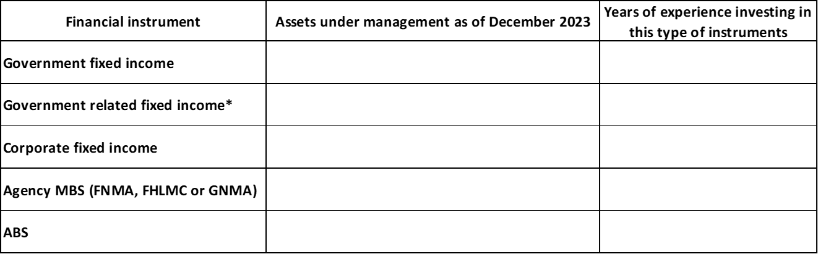

- Custody for the Bank’s assets is provided by the Bank’s custodians, and Candidates (or their Affiliates) will not be permitted to custodialize the Bank’s assets. Please confirm that the Responsible Party will comply with this requirement.

SECTION B – CUSTOMER SERVICE
The Bank expects the selected firm to have a dedicated and efficient customer service team that understands the Bank’s specific needs as a central bank. Additionally, the firm must be willing to prepare monthly performance and risk presentations, to regularly participate in conference calls with the Bank’s staff, and to prepare an annual review of the portfolio to be presented in meetings with the Bank’s staff.
- Please confirm that the firm would be able and willing to provide the services described above. Please describe the company’s capabilities and strengths that will allow it to meet the aforementioned requirements and the Bank’s client service needs.

- Please provide a brief description of your customer service program Additionally, please complete the following table with the information of the customer service employees who would be directly involved with the Bank’s account, including the most important point of contact and his/her/their location.

Table B1
* For the Education column, if having more than one degree, please provide all of them.
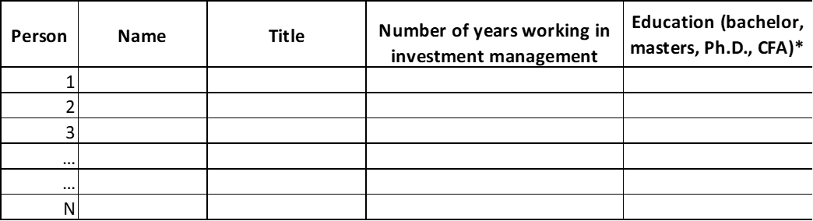
- Please briefly explain your standard procedures to resolve the following situations:
- Breach of the investment guidelines.
- Client requests/inquiries.

- BdlR requires monthly reports that include information such as: market analysis and economic outlook, portfolio breakdown (i.e. currencies, sectors, credit ratings), performance attribution, risk measures (i.e. tracking error, VaR, duration). Please provide a sample of the monthly portfolio review report that you would provide to attend BdlR’s needs.

BACK-OFFICE PROCEDURES
- Briefly describe your back-office operations including:

- Post-trade activities: trade confirmations, trade instructions, settlements. Indicate your straight- through processing (STP) rate by transaction type.
- Daily sweep of funds (USD): if BdlR has executed a sweep agreement with the custodian for the USD account, how do you process trade instructions to be executed before funds are automatically swept to the Money Market Fund (e.g., sweep cutoff: 4:00 pm and fund close: 5:00 pm ET) to prevent settlement failures or overdrafts in the account?
- Collateral management: trade instructions, collateral agreements set-up and operationalization of parameters. What is your collateral exchange policy for each type of instrument (e.g., MBS, FX forward, OTC swaps, repos, etc.)? What is your policy to maintain/monitor cash balances at Futures Commission Merchants (FCMs) (e.g., buffer limit, reconciliation frequency, daily margining, single or multi-currency margining, measures to prevent incurring negative interests?
- CFTC Regulatory: Monitoring the futures/cleared swap portfolio to avoid a situation that might lead to a cessation of the “Ordinary Course of Business” (as described in CFTC Advisories No. 19-17 and 20-28, and as the same may ultimately be codified). Indicate the operational aspects of the implementation of these CFTC Advisories regarding limited recourse and maintenance of the segregation among accounts. If you have established a protocol with FCMs, custodians and clients, please outline the main components of the protocol, such as rights and remedies, deadlines, communication methods, escalation procedures.
- Monitoring and reconciliation: Daily reconciliation vs. custodian and FCM cash activity reports (balances, debits, and credits), exceptions identification, monitoring and escalation procedures.
- Reporting: report production and report customization.

- How do you notify clients of changes in your internal back-office procedures? Do you conduct (or take into consideration) test stages with clients before the effective date of the implementation of those changes?

- Describe your technological infrastructure and connections among the different systems involved in the back-office activities.

- Indicate the level of assets under management you have with each of the below entities (which are the Bank’s current custodians and clearing brokers) and describe the level of automation and connections in each case with:

- JP Morgan Chase Bank N.A. located in New York City - CHASUS33XXX
- State Street Bank & Trust Company - located in Boston - SBOSUS3UXXX
- JP Morgan Securities LLC
- Goldman Sachs & Co

- Indicate the means you would use to communicate trades to the Bank’s custodians, to the clearing broker and the time at which instructions are sent. Please provide an example for each transaction type (forex, fixed income, futures, mortgages, TBAs, cash and securities for collateral, cash movements to and from the Bank’s custodians and the clearing broker). If all trades will be instructed to the Bank’s custodians via SWIFT, please specify the message types used. Which means do you use alternatively in the case of a SWIFT contingency?

- Do you settle FX transactions via CLS? Describe the instruction and communication processes with the custodians.

- Do you perform back-office activities by yourself or are such activities outsourced to an affiliate or a third party? If such activities are outsourced/subcontracted (either to an affiliate or third party), please provide the name of the company to which such activities are outsourced/subcontracted and describe your monitoring and tracking out procedures to assure that the company to which such activities are outsourced/subcontracted complies with the requirements? Are you considering outsourcing/subcontracting of any applicable back-office activities (either to an affiliate or third party) in the next two (2) years?

- How do you monitor and how do you implement changes in the custodian and clearing broker related to operational procedures (such as deadlines, settlement instructions, market, and regulatory requirements)?

CLIENT SERVICE FOR BACK-OFFICE ACTIVITIES
- Describe the communication procedures with clients and with custodian banks. Include degree of automation, timeliness, escalation procedures and controls in place and back-up structure for the client service group to guarantee a timely and effective response.

- Considering that BdlR is in Eastern / Central Standard Time (NY), depending upon the time of the year, indicate how and when clients can contact you.

- Please provide your views on the major issues facing the industry and those that you anticipate will demand attention in the next five (5) years. (We are referring to issues relating to custody, settlements, accounting, and any other topic that can be considered as relevant to back offices).

- Do you produce bulletins or news flashes on the topics mentioned in the above question which could be shared with BdlR?

REPORTING
- Does your firm have the capability to develop, configure and generate reports resulting from specific requirements from the client? Please, also consider in your answer, modifying your standard reports to satisfy a specific requirement from the client, such as format, content, frequency, delivery method or special considerations (e.g. if there is no trading activity, the external manager will send a report or message with a note: “No trading activity to report for [date]” or changes in the format reports will be informed to BdlR with at least one (1) month in advance, considering that such reports may be interfaced as part of the BdlR’s automatic procedures).

- Please indicate if you have the capability to protect your reports using IT security tools as encryption or passwords, keeping the integrity and confidentiality of sensitive information. Please, also consider in your answer if this is a standard automatic process within your systems, or if it would require additional non-automatic or human intervention.

- Please indicate in the table below if that you can comply (Yes/No) with providing the below listed reports on the required format and indicate whether reports will be delivered via email, web platform, swift, fax, other. If you consider necessary, please include any comment or additional specifications on the last column.

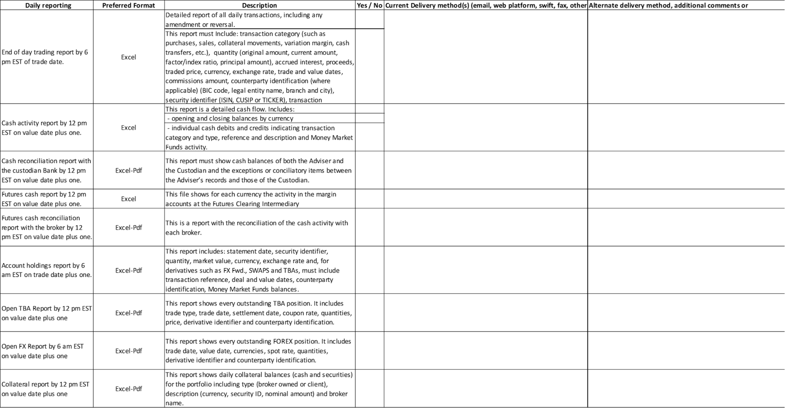
Table B2
Table B3
* “Business day” means a day other than a day on which banks in the jurisdiction of the account manager are generally closed for business, Saturday or Sunday.
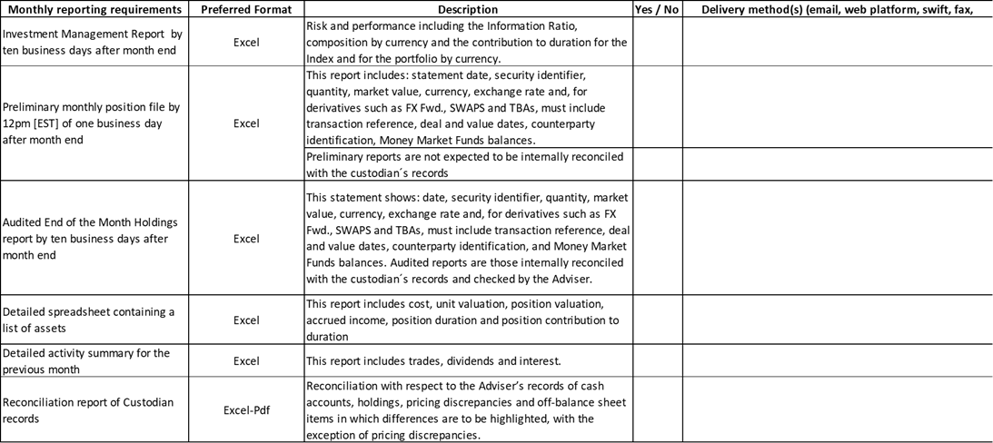
** “Audited” means that these reports should be internally reconciled with the custodian’s records and reviewed and commented by the investment manager. The “audited” reports are different from the ones listed as “preliminary”, as preliminary reports do not need to be reconciled.

MANAGEMENT OF SETTLEMENT FAILURES
- How do you monitor trade matching and settlement status to avoid or minimize settlement failures?

- Describe your escalation and revision procedures of failed trades for further analysis and risk management. Do you keep record of the failures due to operational risk? Describe your internal policy to resolve the issue, i.e., guidelines such as timeliness, proceeds amount of the failed trade, financial consequence, other.

- When overdrafts occur on cash accounts at the custodian and/or margin accounts at FCMs:
- What is your policy to recover the financial consequences it might cause?
- What market practices do you use to recover the financial consequences due to settlement failures?
- Do you consider overdrafts as a financial impact associated with a settlement failure?

- Would it be possible for your organization to implement a control by which you would manage the margin account in the FCM in such a way that no overdraft charges (interest rates debited by the broker on negative balances) are applied to the account in any given month for more than US$500? Please, take into account that the idea is to control this limit on an aggregated basis, which means adding overdraft charges in all accounts held in the broker for the portfolio that your firm would manage on behalf of BdlR. For the sake of clarity, please be aware that negative interest rates on positive balances would not be part of this control.

- Aiming at a higher standard, could you please indicate if you would have the way to manage the FCM’s account so that that no overdraft charges are applied by the FCM at all?

- Please indicate if you can provide the following information for settlement failures upon BdlR’s request:
Transaction Type | Purchase, sale, Funds transfer, fx, collateral delivery, collateral receipt
Event type | - Settlement failure – purchase  - Settlement failure – sale  - Late receipt of funds
Currency
Amount | Net amount
Security ID | ISIN
Cause of the exception | - Short of shares  - Short of cash  - Wrong instructions  - Other
Responsible for the exception | - Custodian  - Counterparty  - FCM  - Investment Manager  - Other
Market practice | - TMPG, ISITC, other
Improvement Actions | (If applicable)
Event Status | - Pending for settlement  - Settled and closed  - Associated consequence
Consequence | - TMPG Claim  - CSDR penalties  - Overdraft charges  - Cost of doing business  - Write-off  - Other
Charges | Net charges
Actions | - Custodian to reimburse  - IM to approve reimbursement  - Counterparty to reimburse
Comments

- Please confirm if you use any of the following market practices on settlement failures, and if you consider them to cover all the possible trades you will conduct on behalf of the portfolio.
  - ISITC
  - TMPG
  - JSDA
  - ICMA
  - BAFT-ISA Interbank Compensation rules
  - European Interbank Compensation Guidelines
  - Canadian Payments Association LVTS rule 14 Claims and Compensation.

Which other market practices or internal policies do you follow? Do you anticipate any of the markets in which the portfolio will be invested has special legal requirements related to settlement failures (for example, restricted market, collateralization, or a market practice such as TMPG in the USA or JSDA in Japan)?

- How are you monitoring settlement failures and potential cash penalties under CSDR? Do you have systems in place to track failed trades?

- What processes have you implemented to minimize the occurrence of settlement failures that would trigger cash penalties? How did you prepare operationally for CSDR?

- How are cash penalties for settlement failures handled? What is your reimbursement policy when a cash penalty impacts a client account?

- How are you communicating with trading counterparties and Central Securities Depositories (CSD) to ensure alignment regarding settlement procedures to avoid settlement fails under CSDR?

- Based on the nature of the investment activity that you anticipate for BdlR’s portfolio, is there any regulatory requirement that would apply?

RECORD KEEPING
- Describe your record keeping policies in terms of: timelines, ability to provide supporting documentation to the client, and the availability for inspection and audit purposes by the Bank or any person designated by the Bank.

RESEARCH AND TRAINING
- Does your firm provide standard training programs for its customers on topics such as settlement, safekeeping, accounting, risk control, performance measurement, post trade market practices, regulatory updates, etc.? If so, do you currently provide, or would you consider providing, customized training in such topics for a customer’s staff?

TAXES
- Describe the procedures you have in place, or possibly will implement, to monitor the tax status of investments and which actions are taken when there is no available/updated documentation.

SECTION C - INVESTMENT PROCESS / RISK MANAGEMENT
- Please complete the following table with information regarding the portfolio management team that would be directly involved with the Bank’s account. Provide a brief biography of each as an annex.

Table C1
* For the Education column, if having more than one degree, please provide all of them.
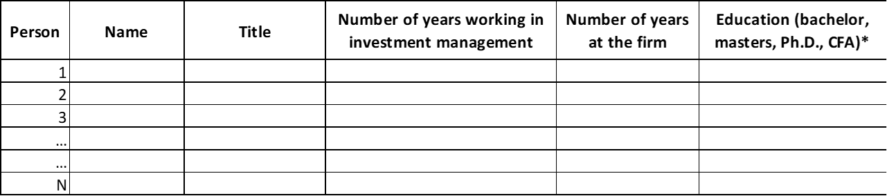

- Please provide the number of investment professionals who left the firm during the last three (3) years. Briefly detail the reasons and year in which each of them left.

- Please describe minimum qualifications for your staff and briefly comment about internal training programs for portfolio managers, risk managers, traders, research analysts, operational analysts, etc.

INVESTMENT PROCESS
- Please briefly describe the theory and beliefs underlying the firm’s investment philosophy in fixed income (quantitative or fundamental, top-down or bottom up). If possible, describe how this is evidenced in the firm’s investment process.

- Please provide the organizational structure and main functions of the areas involved in the investment process (portfolio management, risk management, compliance, internal audit, research, etc.). Indicate the number of employees in each area.

- Please detail how investment decisions are made (people/areas involved, processes, frequency). Are there any committees where investment ideas are discussed? Who is accountable for the investment decisions?

- Do you have specialized teams responsible for making investment recommendations in the following sectors: interest rates, currencies, agency MBS, corporate debt, government related debt and asset backed securities (ABS)? If so, please provide the following information for those teams:

Table C2
* For the Education column, if having more than one degree, please provide all of them.
** The Government related sector is composed by the following subsectors: supranational, government guaranteed agencies, government owned agencies / government sponsored agencies and local authorities.
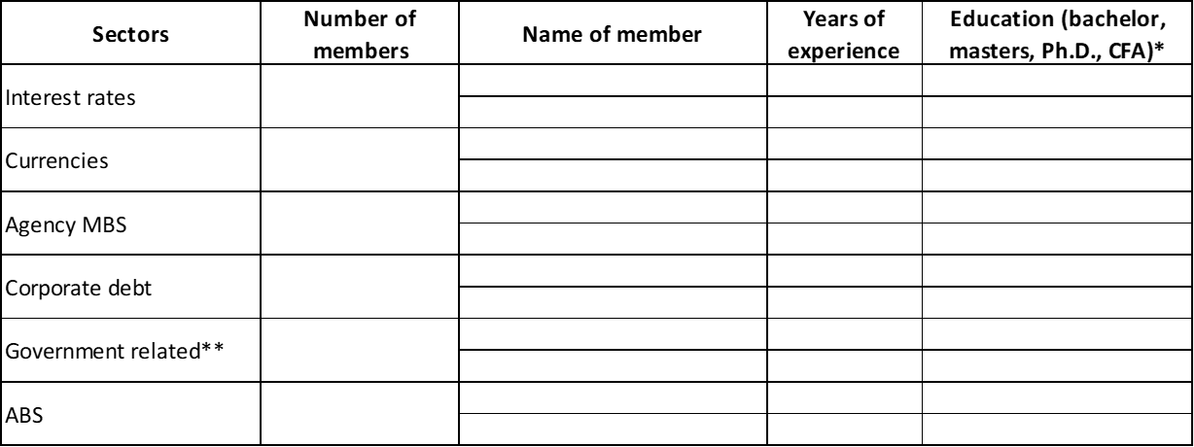

- Please explain the role of the portfolio manager in charge of the account. Does the portfolio manager participate in the decision-making process? Is the portfolio manager allowed to deviate from the overall investment strategy of the firm? Does the portfolio manager’s compensation depend on the performance of the account?

- Do you have separate research teams in economics and quantitative analysis that provide support to the portfolio management function? If so, please provide the number of dedicated members.

- Has your investment process experienced significant changes during the last five (5) years? Do you envision significant changes to that process in the near future? Please briefly elaborate if needed.

- Please describe your approach to risk budgeting and portfolio construction. Do you use any quantitative tools in this process?

- If your firm has previously worked with the Bank as an external manager, please explain what has changed in your investment process.

- Please describe how the analysis of Environmental, Social, and Governance (ESG) factors is incorporated into your investment and risk management processes for fixed income mandates.

- Please describe, if applicable, how artificial intelligence is incorporated into your investment and risk management processes for fixed income mandates.

RISK MANAGEMENT
- How is risk management integrated in your investment process? Is the risk management function independent from portfolio management? Can risk managers recommend changes to the portfolio? Describe your firm’s approach to risk management regarding both financial and non-financial risks.

- Please explain what measures are used to assess market risk.

- Please state if your firm has performance and risk attribution systems and if so briefly describe them, including whether such systems are proprietary or externally provided. Please also provide a sample of a performance attribution and risk attribution report and indicate if such report would be made available to a client at least on a monthly basis.

- Do you have specialized teams involved in the market and credit risk management of the portfolios? If so, please provide the following information:
Table C3
* For the Education column, if having more than one degree, please provide all of them.
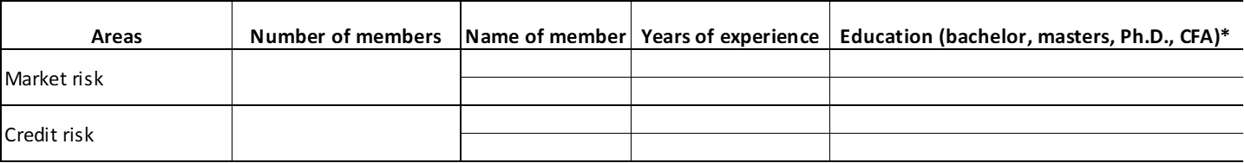
- Do you have a dedicated team for credit risk assessment of individual issuers? Please explain in detail your process and methodology to assess credit risk of individual issuers.

- Please explain in detail your process to assess credit risk of asset backed securities (ABS).

- Regarding compliance:

- What is the scope of your compliance function? What tools do you have in order to monitor compliance with portfolio guidelines and internal policies and procedures at all times? Please specify if you have both pre-trade and post trade compliance systems.
- Please describe the role of compliance officers, specifying their independence from the investment team and their responsibilities towards clients.

- Has your risk management process experienced significant changes during the last five (5) years? Do you envision significant changes to such process in the near future? Please briefly elaborate if needed.

- Please describe how your firm would monitor and ensure compliance with the Bank’s investment guidelines.

- In addition to the portfolio-related risk management policies and procedures discussed above, please describe your firm’s enterprise-wide risk management, addressing, among other things, operation, legal, compliance and counterparty risk.

- Please describe your firm’s Business Continuity and Operations Plan.

- Please describe your firm’s policy relating to controls over vendors and affiliates that may be involved in the performance of services under the asset manager relationship or that may have access to confidential information of the Bank.

- Does your firm maintain errors and omissions insurance or other potentially relevant insurance policies? If so, with which insurers and what are the policy limits?

SECTION D – TRAINING / KNOWLEDGE TRANSFER
One of the objectives of the Bank’s External Manager Program is to acquire knowledge and training through our external managers. The selected firm is expected to provide, at minimum, five (5) days of training for two (2) officers or ten (10) days of training for one (1) officer per year, including accommodation and transportation costs. This training must suit the Bank’s needs and be offered for both junior and senior staff.
- Please acknowledge that the firm would be able and willing to provide at least this level of service.

- Please further elaborate on training / knowledge transfer that your firm provides to clients. Please detail seminars, webinars or other events organized, the target audience and the type of clients that attend, and the staff and resources that your firm makes available. Include additional information if considered pertinent.

- Support to the Bank’s research efforts is another key element of the External Management Program. Do you have a dedicated team that provides support to the client’s projects/initiatives? If so, please detail the pool of available resources/services that could be made available to the Bank.

- Please describe any other specific products available to clients, for example, access to research papers, internal research, or conference calls on special topics.

- What other value-added services do you offer to clients?

SECTION E – HISTORICAL PERFORMANCE
- Please provide in a separate excel file audited figures of portfolio and benchmark monthly returns during the last five (5) years (from January 2019 to December 2023) of Global Fixed Income Short Duration composite(s) similar to the Bank’s proposed mandate in terms of the type of client and permitted asset classes. Returns are to be calculated in compliance with GIPS.

- Please provide a detailed description of the composite(s) and the benchmark(s), including credit rating breakdown, type of eligible asset classes, duration, and the average size of the assets under management.

- If your firm does not comply with GIPS, please provide a description of the standards that it employs in calculating its returns.

SECTION F – LEGAL, COMPLIANCE AND OTHER MATTERS
- Do your Anti-Money Laundering (AML)/Combating the Financing of Terrorism (CFT) Program and AML policies and procedures comply with current AML legislation, regulations and guidelines issued by the regulatory bodies in the jurisdiction in which you operate?

- Do you have an Anti-Bribery and Corruption Compliance Program (ABC)?

- Do your ABC Program, policies and procedures comply with current ABC legislation, regulations and guidelines issued by the regulatory bodies in the jurisdiction in which you operate and/or inter-jurisdictional systems (i.e. FCPA)?

- Describe your firm’s code of ethics and how compliance with the code is monitored.

- Describe your firm’s conflict of interest policy and how compliance with the policy is monitored.

- Does your firm or its Affiliates have any real or potential conflicts of interest (personal or organizational) with the Bank? If so, how does your firm propose to avoid, mitigate or neutralize such conflicts of interest?

- Describe how (if at all) your proprietary interests or interests of your other clients might affect or conflict with your duties to the Bank.

- Describe your firm’s confidentiality policies that would protect against both non-use and non-disclosure of confidential information of the Bank, including without limitation with respect to employees of your firm accessing confidential information of the Bank outside your offices (including as a result of remote work accommodations).

- Describe how the firm determines, adheres to, measures, and reports on standards for best execution with brokers, dealers, and other counterparties in compliance with the Bank’s investment guidelines.

- As described above under the “The Bank’s Investment Management Agreement” heading, the Bank has a standard New York or English law governed Investment Management Agreement that it signs with each of its managers within the External Management Program that will only be subject to minor modifications.

- The Investment Management Agreement provides (i) that the Bank does not agree to waive, and specifically reserves its right to, any immunity to which it or its assets may be entitled on the grounds of sovereignty or other similar grounds, and (ii) the external managers will only have recourse to the given portion of assets under management.
- Under the Investment Management Agreement, asset managers have discretion as to which assets and securities to trade (within the Bank’s investment guidelines). However, if an asset / security is established under an agreement (e.g., transactions under an ISDA Master Agreement or an MSFTA) that is in the name of or binding on the Bank, the asset manager must comply with the Required Terms that are provided in the Investment Management Agreement.
- Please be aware that BdlR is considering to be included under the external manager’s umbrella ISDA Master Agreements, among others, subject to the compliance by the external manager with the Required Terms.

Please confirm that your firm will comply with (a), (b) and (c) above.

- Please confirm that your firm would agree to notify at the earliest possible of (and update BdlR on) litigation or any actions or investigations by governmental or regulatory agencies that could adversely affect your ability to fulfill your functions as asset manager.

- What challenges have you observed, from a legal and compliance perspective, in implementing investment management programs for other central banks?

- How have you addressed challenges, if any, you described in Question 87.

- Describe the standards used by you to implement your cybersecurity system. Also, describe your due diligence related to cybersecurity programs of third- and fourth-party vendors you would utilize on behalf of the Bank.

- Please confirm that there is no legal, regulatory or administrative proceeding threatened or pending that could adversely affect your ability to perform or comply with your role as an external manager to the Bank.

- Please confirm that there are no legal impediments or operational impediments that would reasonably be expected to prevent you from carrying out your responsibilities as an external manager to the Bank.

Annex 1. Instructions for the Proposal

Please keep in mind that the Bank will only consider Proposals that are delivered on time and received at the electronic address according to the procedure stated below.
The term “Proposal(s)” should be understood as the group of documents consisting of:
- Responses to the Questionnaire
- Certification as to Satisfaction of the Minimum Selection Criteria for Consideration
- Compliance Certification duly signed (in the form of Annex 2 attached hereto)
Additional Documentation: Audited consolidated financial statements as of December 31, 2023, Certificate of good standing, Certificate of incumbency for authorized signatories (for the Certification as to Satisfaction of the Minimum Selection Criteria for Consideration and for the Compliance Certification), SOC 1 or ISAE 3402 report issued by an independent auditor on the effectiveness of your internal controls for 2023, and Registration as investment advisor.
Proposals should be submitted in written form in English. The instructions for sending the Proposal are as follows:
They must be submitted via e-mail only to the address DA-RecepcionOfertas@banrep.gov.co with the following subject matter: “RFP 2024 Foreign Reserves. Final Response”. The body of the e-mail shall visibly state the complete name and contact data of the Candidate, including its physical and electronic address. The Responses to the Questionnaire must be received at the e-mail address indicated above no later than by 23:59 (Bogotá time), June 14th, 2024. The Bank will not consider e-mails received after the date and time indicated above. The documents must be sent as an attachment(s) to an e-mail in PDF format with the exception of the tables that can be found in the excel file included in this RFP, which should also be sent in .XLSX format. The size of each email must be equal or less than 10 MB because the e-mail server of the Bank does not accept files of larger sizes. If you need to send separate e-mails, please take into account that they should be numbered (for example, e-mail 1 of 5) and come from the same e-mail address. The email address provided above [DA-RecepcionOfertas@banrep.gov.co] is exclusively for sending the Proposal. Participants should refrain from using such email address for any other purpose.
The submission of the Proposal by the Candidate will be evidence of its understanding and acceptance of the conditions set forth in this RFP.

Annex 2. Compliance Certification

Form 01-A.
Affidavit Statement – Responsible Party
Date (dd/mm/yyyy):
Responsible Party / Legal Entity  I, <<Name>>,  Acting as Legal Representative of the Responsible Party: <<Name>>  with ID No.<<ID number>> and  ID No. of the Legal Representative <<identification number>> | Individual / Natural Person  I, <<Name>>,  with ID No. <<identification number>>
Hereby state under oath the following:
According to Article 7° of Banco de la República’s Rules on Contracting; the undersigned, the Responsible Party that I represent and the Responsible Party’s partners are not involved in any cause to be ineligible or unqualified, in accordance with the aforementioned Rules and Article 8° of Law 80 of 1993 (Colombian Law), and with other provisions that modify, substitute or add them, or that establish causes to be ineligible or unqualified to contract with the Colombian State, which I declare to know.
Note: It is necessary to verify that the Responsible Party’s partners and executives do not have a kinship or patrimonial relationship with Banco de la República’s employees that appear in the list available in the following link: https://www.banrep.gov.co/sites/default/files/informacion-cargos-nivel-directivo-asesor-control-y-miembros-jd-planta.xlsx.

______________________________________
Responsible Party’s Legal Representative Signature
ID Number:
Responsible Party Name:

Annex 3. Authorization for the processing of personal data (image) of a person of age for internal use by Banco de la República

- Important information - Authorization to process personal data (image):

Reference: 2024 Request for Proposal for External Managers of the Foreign Reserves – Banco de la República, [Name of Responsible Party].

In compliance with Personal Data Protection Regulations, I, __________________________, of age, domiciled at __________________________________________________, ID/Passport No.__________________ from ______________, hereby authorize BANCO DE LA REPÚBLICA (the “Bank”) to carry out treatment (by collection, storage, use, circulation, or erasure) of my image (name, pseudonym, voice, identification, figure, physiognomy, etc.) and other personal data that I may provide in the course of visits, telephone and/or video conferences, and other stages of this selection process with the Bank that may be recorded in video and audio for the purpose of using them internally to analyze, verify and evaluate as well as other procedures required by the Bank pursuant to this selection process, which may include its storage in internal repositories for its conservation, as well as for the construction of indicators and statistics for monitoring and control of these processes and activities, legal controls, and to fulfill other constitutional and legal functions of the Bank.

For this purpose, the Bank hereby informs that: (i) The processing of personal data will be carried out in accordance with the general policies or guidelines available at https://www.banrep.gov.co/en/general-policies-and-guidelines-personal-data-protection, in the section “Protection of personal data - Habeas Data,”; (ii) the Bank is committed to the security and protection of the personal data it is responsible for, and that its information management systems are certified to ISO 9001 and ISO/IEC 27001, the latter regarding information security. Thus, many of the policies and standards of the institution's information management system are focused on protecting the confidentiality of the information; therefore, some of the mechanisms that support these policies and standards include network access control and/or authentication devices, software to manage authorization levels, and monitoring the activities in the system and keeping track of these activities. The preservation of documents and information is made in compliance with and within the terms set forth in Article 55 of Law 31 of 1992; (iii) The answer to questions concerning sensitive data is optional and, if provided, their treatment is authorized for the purposes described above; (iv) You may access, know, update and rectify such data; be informed of the use of such data; submit inquiries and complaints regarding the treatment of such data; revoke this authorization or request the erasure of the data whenever appropriate, and all other rights conferred by the Law; (v) To exercise such rights, you can contact the Sistema de Atención a la Ciudadanía (SAC): personal attention centers, telephone centers (national toll-free line: 01 8000 911745), or via web. For more information, please visit Banco de la República's website at https://www.banrep.gov.co/es/transparencia/atencion-ciudadania.

General Data - Responsible: BANCO DE LA REPÚBLICA, NIT No. 8600052167, Main Office: Bogotá D.C. Contact: Through the Sistema de Atención a la Ciudadanía (SAC).

Signature: _________________________
Name: ____________________________
ID/Passport No: ____________________________

The Bank reserves the right not to appoint any new, or to appoint more than one, external asset manager. All references herein to a selected Candidate include each such selected Candidate.
The approximate amount of the portfolio under management is US$1.7 billion. This is an approximate amount, only for reference purposes. The Bank can modify the amount under management and the investment guidelines at any time.
Measured as the ex-ante volatility of the excess returns versus a given benchmark.
The 2023 version of the Foreign Reserves’ report is available in Spanish at https://www.banrep.gov.co/es/publicaciones-investigaciones/informe-reservas-internacionales/2023.
This ratio must be calculated with the audited financial statements as of December 31, 2023. If the Responsible Party does not issue financial statements, the parent company audited financial statements are allowed.
In this RFP, “Affiliate” means any entity or legal organization that controls, is controlled by or is under common control, with another entity.
For the sake of clarity, current investment managers of Fideicomiso FAE (Savings and Stabilization Fund of the Republic of Colombia, which is administered by the Bank), and their Affiliates are eligible to participate in this RFP, provided that they comply with all the requirements for eligibility set forth herein.
This is in case physical travel is not possible or telephone or video conferences are deemed more convenient or appropriate by the Bank.
See Annex 3 to this RFP: “Authorization for the processing of personal data (image) of a person of age for internal use by Banco de la República.”
This provision does not apply to transactions solely made pursuant to a trade confirmation.
For the sake of clarity, current investment managers of Fideicomiso FAE (Savings and Stabilization Fund of the Republic of Colombia, which is administered by the Bank), and their Affiliates are eligible to participate in this RFP, provided that they comply with all the requirements for eligibility set forth herein.
This ratio must be calculated with the audited financial statements as of December 31, 2023. If the Responsible Party does not issue financial statements, the parent company audited financial statements are allowed.
If the Responsible Party does not issue financial statements, the parent company audited financial statements are allowed.
A “Certificate of Good Standing” or its equivalent is an official document that certifies the legal existence of the Responsible Party and that the entity is authorized to do business in the place where it is registered.
If your firm is registered with the U.S. SEC, both Part 1 and Part 2 of Form ADV should be provided. For other jurisdictions, please provide equivalent documentation, if applicable.
A settlement failure is considered as a transaction not settling in due time, including those settling after the cutoff time of the market.
The Central Securities Depositories Regulation (CSDR) aims to harmonize the timing and standards of conduct in the European securities settlement industry.
In the event that travel is not possible due to travel restrictions, or as deemed more convenient or appropriate by the Bank, the Bank will expect an equivalent amount of virtual training and support.
If your firm is registered with the U.S. SEC, both Part 1 and Part 2 of Form ADV should be provided. For other jurisdictions, please provide equivalent documentation, if applicable.
Name of the Legal Representative of the Responsible Party signing the form.
Name of the Responsible Party signing the form.
Identification number or tax identification number of the Responsible Party signing the form.
Identification number of the Legal Representative of the Responsible Party signing the form.
Name of the Individual signing the form.
Identification number of the Individual signing the form.
Central Bank of Colombia.
Resolution No. 2 of 2010 of Banco de la República’s Board Directors. The Rules of Contracting can be consulted at https://www.banrep.gov.co/es/marco-normativo-adquisiciones.
Please refer to the following link: http://www.secretariasenado.gov.co/senado/basedoc/ley_0080_1993.html#8
In Colombia, Law 1266 of 2008, Law 1581 of 2012, and Decree 1074 of 2015.

